Experiment:14 Date:1/08/2027

TIC TAC TOE

Aim
To write and implement a Python program using the Minimax algorithm for gaming. The program implements a simple Tic-Tac-Toe game in which the computer uses Minimax to make the best possible move.

Algorithm(MINIMAX):
- Start the Tic-Tac-Toe game with an empty 3×3 board.
- Display the board.
- Allow the player to enter a position from 1 to 9.
- Check whether the selected position is empty.
- Place X for the player.
- Check whether the player has won or the game is a draw.
- If the game is not over, call the Minimax algorithm.
- Minimax evaluates all possible future moves:
  - Maximizing player → Computer O
  - Minimizing player → Human X
- Select the move with the highest score for the computer.
- Display the computer's move.
- Repeat Steps 3–10 until a player wins or the game ends in a draw.
- Stop the program.

PROGRAM:

# Minimax Algorithm for Tic-Tac-Toe

board = [" " for _ in range(9)]

def display_board():
print()
print(" " + board[0] + " | " + board[1] + " | " + board[2])
print("---+---+---")
print(" " + board[3] + " | " + board[4] + " | " + board[5])
print("---+---+---")
print(" " + board[6] + " | " + board[7] + " | " + board[8])
print()

def check_winner(player):
winning_positions = [
[0, 1, 2],
[3, 4, 5],
[6, 7, 8],
[0, 3, 6],
[1, 4, 7],
[2, 5, 8],
[0, 4, 8],
[2, 4, 6]
]

for position in winning_positions:
if all(board[i] == player for i in position):
return True

return False

def is_full():
return " " not in board

def minimax(is_maximizing):
# Computer wins
if check_winner("O"):
return 1

# Human wins
if check_winner("X"):
return -1

# Draw
if is_full():
return 0

if is_maximizing:
best_score = -1000

for i in range(9):
if board[i] == " ":
board[i] = "O"
score = minimax(False)
board[i] = " "
best_score = max(best_score, score)

return best_score

else:
best_score = 1000

for i in range(9):
if board[i] == " ":
board[i] = "X"
score = minimax(True)
board[i] = " "
best_score = min(best_score, score)

return best_score

def computer_move():
best_score = -1000
best_move = -1

for i in range(9):
if board[i] == " ":
board[i] = "O"
score = minimax(False)
board[i] = " "

if score > best_score:
best_score = score
best_move = i

board[best_move] = "O"

# Main program

print("TIC-TAC-TOE USING MINIMAX")
print("You are X")
print("Computer is O")

print("\nPosition numbers:")
print(" 1 | 2 | 3")
print("---+---+---")
print(" 4 | 5 | 6")
print("---+---+---")
print(" 7 | 8 | 9")

while True:
display_board()

# Player input
position = int(input("Enter your position (1-9): "))

if position < 1 or position > 9:
print("Invalid position! Enter 1 to 9.")
continue

if board[position - 1] != " ":
print("Position already occupied!")
continue

board[position - 1] = "X"

if check_winner("X"):
display_board()
print("You WIN!")
break

if is_full():
display_board()
print("GAME DRAW!")
break

# Computer move using Minimax
computer_move()
print("Computer selected a move.")

if check_winner("O"):
display_board()
print("Computer WINS!")
break

if is_full():
display_board()
print("GAME DRAW!")
break

OUTPUT:

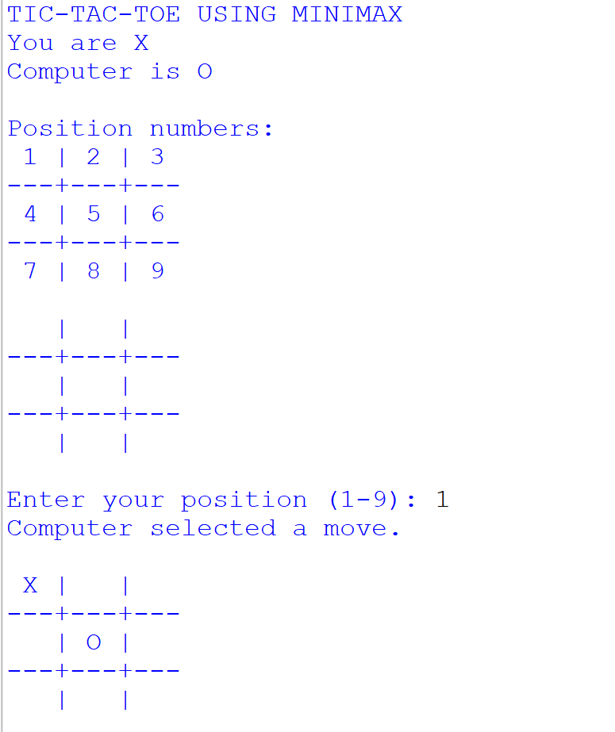

Result:
Thus, the Minimax algorithm was successfully implemented in Python for a Tic-Tac-Toe gaming application.

